Cisco Static Routing & Connectivity Verification
Topology, routing-table interpretation, interface verification and ping testing

1. Network Topology
The topology contains two IP networks connected through a Cisco router. Win1 is connected to Ethernet0/0 and Win2 is connected to Ethernet0/1.

2. IP Addressing
Device | Interface | IP Address | Purpose
Win1 | NIC | 50.0.0.10/8 | Host in 50.0.0.0 network
Router | Ethernet0/0 | 50.0.0.1/8 | Gateway for Win1
Router | Ethernet0/1 | 60.0.0.1/8 | Gateway for Win2
Win2 | NIC | 60.0.0.10/8 | Host in 60.0.0.0 network

3. Router Configuration
Configure the router interfaces with the gateway addresses:
enable
configure terminal
interface Ethernet0/0
ip address 50.0.0.1 255.0.0.0
no shutdown
exit
interface Ethernet0/1
ip address 60.0.0.1 255.0.0.0
no shutdown
exit

4. Verify Interfaces
Use the following command:
show ip interface brief
Both Ethernet0/0 and Ethernet0/1 should show Status = up and Protocol = up.

5. Understand C and L Routes
C = Connected route. It represents a network directly connected to a router interface.
L = Local route. It represents the router's own interface IP address and traffic destined to the router itself.
Example:
C 50.0.0.0/24 → directly connected through Ethernet0/0
L 50.0.0.1/32 → router's own Ethernet0/0 IP
C 60.0.0.0/24 → directly connected through Ethernet0/1
L 60.0.0.1/32 → router's own Ethernet0/1 IP

6. Check the Routing Table
show ip route
For this simple topology, an additional static route is not required because both destination networks are directly connected to the same router. The router automatically installs connected (C) and local (L) routes.

7. Ping / Connectivity Verification
Test | Command | Purpose
Win1 → Router | ping 50.0.0.1 | Tests Win1 to its default gateway.
Win1 → Win2 | ping 60.0.0.10 | Main end-to-end test across the router.
Win2 → Router | ping 60.0.0.1 | Tests Win2 to its default gateway.
Win2 → Win1 | ping 50.0.0.10 | Tests reverse end-to-end connectivity.
Router → Win1 | ping 50.0.0.10 | Tests router reachability to Win1.
Router → Win2 | ping 60.0.0.10 | Tests router reachability to Win2.

9. Interview Explanation
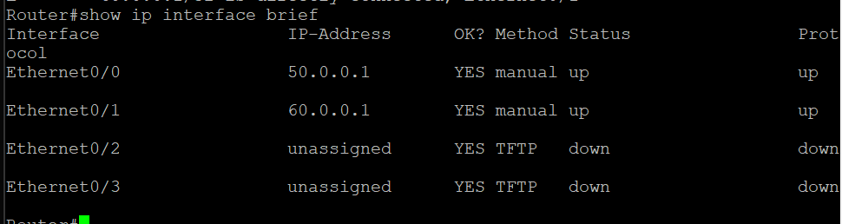
- C means Connected: the network is directly connected to the router. L means Local: the router's own interface IP. In this topology, static routing is not required because 50.0.0.0/24 and 60.0.0.0/24 are directly connected networks. If another router were introduced and a destination network were behind that router, a static route or dynamic routing protocol would be required.
show ip interface Brife:

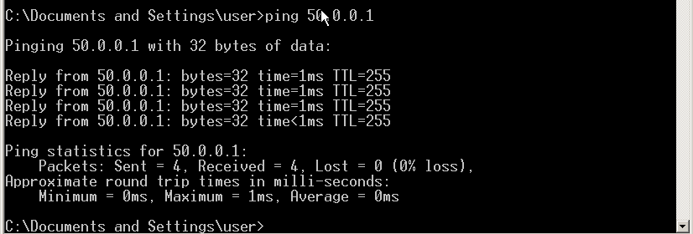
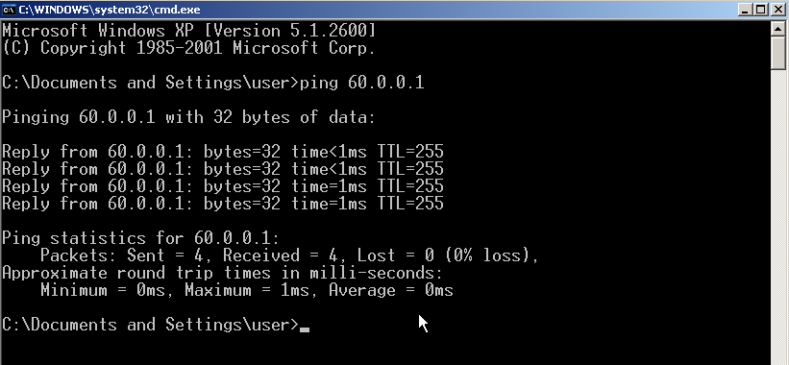
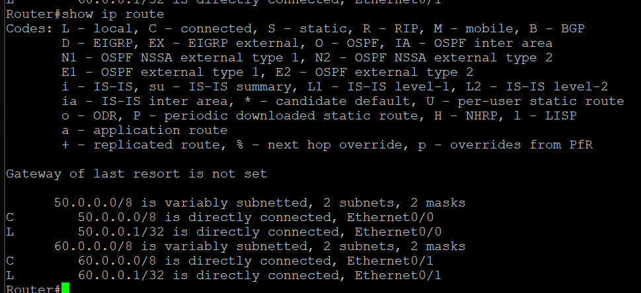
- show ip Route :
C – Directly connected
L-Local connected
Ping 50.0.0.1 Ping 60.0.0.1

